**UNIT TEST REPORT**

**CUNIT TESTING-**

CUnit is a lightweight system for writing, administering, and running unit tests in C.  It provides C programmers a basic testing functionality with a flexible variety of user interfaces.  
  
CUnit is built as a static library which is linked with the user's testing code.  It uses a simple framework for building test structures, and provides a rich set of assertions for testing common data types.   In addition, several different interfaces are provided for running tests and reporting results. These interfaces currently include:

1. **OUTPUT OF CUNIT**

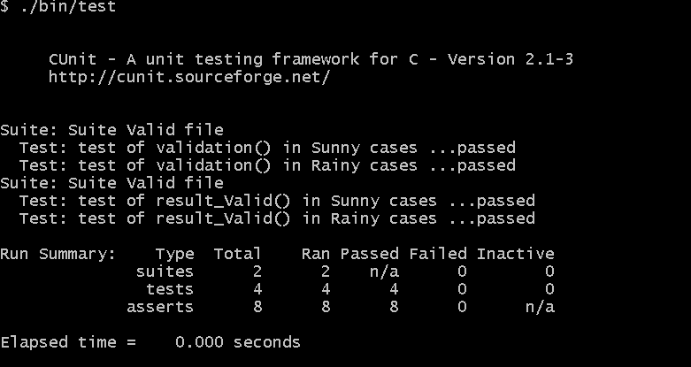

1. **SUITE 1**

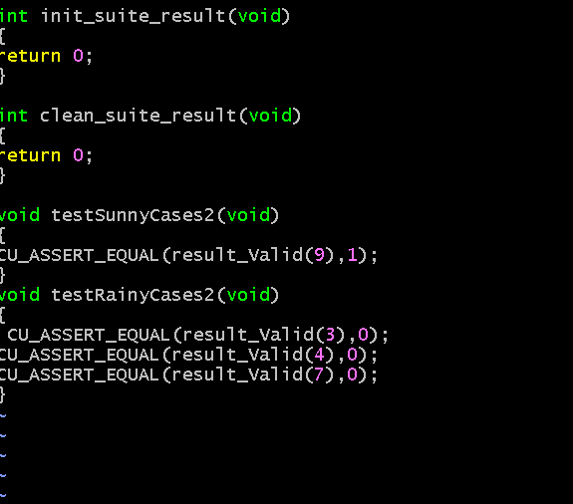

1. **SUITE 2**

